**Problem statement:**

A new barcode inventory managing system is required to manage and keep physical loan files in an inventory for future references purpose. The new system should keep track of, and show the actual status of the documents, both inward and outward process.

**Statement of work:**

**Goals**- To design a new barcode inventory managing system for managing, keeping and retrieving files from an inventory with role access for Admin, Super user and users. The system should generate a report with export option and dashboard for charts. Advance search functionality with filters.

-To achieve milestones and deliver in timebound manner while managing all stakeholders

Classification of given fields into Master, Transactional and Parametric data:

| **Type of data** | **Fields** |
| --- | --- |
| Master data | Barcode number |
| Loan number |
| Document type |
| Transactional data | Inward date |
| Out date |
| Re-inwward date |
| Requested by |
| Approved by |
| Location |
| Parametric data | Remark (In/Out/Re-in) |
|
|

1. Master data: It is fed into the database and is not needed to be chnaged frequently. The three fields in the database will act as identifiers against which transactions will be recorded.
2. Transactional data: Whenever there is an inward or outward process a transaction will be recorded against the given fields.
3. Parametric data: this data will appear as a drop down menu and three given values for remark parameter will be - In /Out/Re-in, if a file is out only Re-in option will appear in value.

The following swimlane diagram shows inward and outward flow of data and the actors involved in carrying out those tasks.

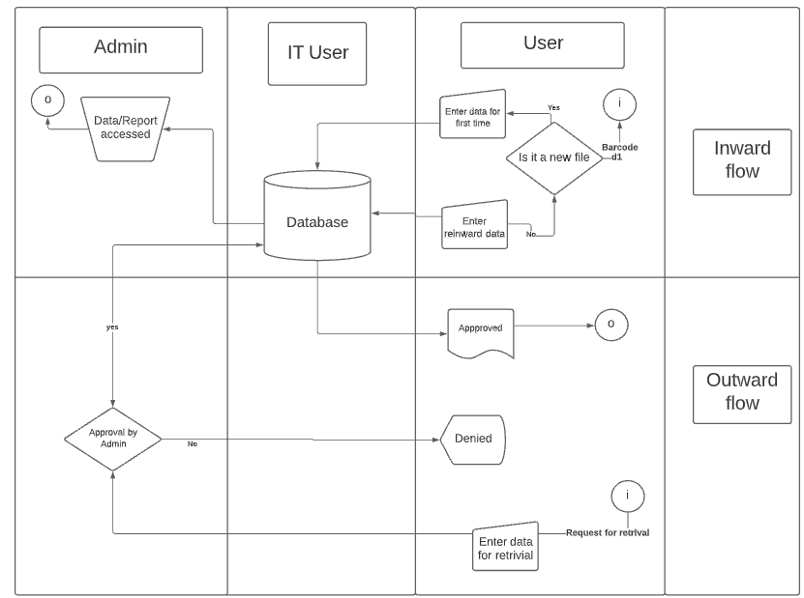

**Project Initiating process group**

Based on given Business case, this statement of work and contract; a Project charter will be created consisting of the following:

Business Case:

Project Justification*:*

Product description*:*

Stakeholders*:*

Resources:

Stakeholder requirement*:*

Constraints and assumptions*:*

General Milestones*:*

**General Milestones to be achieved**

More milestones will be added as OPA and EEF are accessed and progressive elaboration takes place

| **Milestones** | **Description** |
| --- | --- |
| Design flowcharts | Designing flowchart of data and activity charts |
| UI design and approval | Stage wise approval of UI designs for different access users |
| Role access login to Admin | Role access login given stagewise to Admin, super-user and user |
| Reports and Dashboard | Generation of reports and dashboards from infed master data along with advance filter search and export option |
| Developed product | Developing a prototype product |
| Testing | Test run of developed product |
| Re-development | Corrections to be made in product as per findings of test run |
| Final documentation | Completion of corrections and final documentation of product |
| User acceptance testing | Dry run with users and acceptance testing from client |

**Project scope:** Following deliverables are expected out of this project

|  | Description of deliverables |
| --- | --- |
| General deliverables | Project plan |
| Project budget |
| Project charter |
| Specific deliverables | Customer requirements specifications |
| UI designs |
| Backend development of access portals |
| Report and dashboard generation and data export |
| Test system |
| Live system |
| Data migration into the database |
| User training |